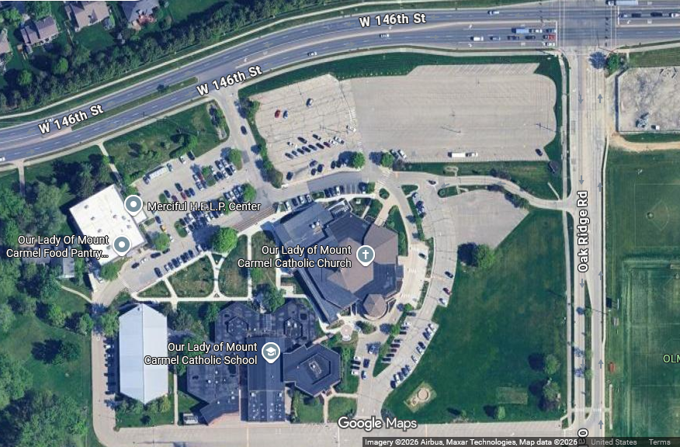
Entrance to Parish Life Center
NCBC meeting location (Door A)
Parking

